
Project Report
GST Hackathon
Pulkit Saxena | 9/21/24 | pulkit21aug@gmail.com

Pulkit Saxena
Email – pulkit21aug@gmail.com
Working Professional
LinkedIn - https://www.linkedin.com/in/pulkit-saxena21/

Contents
Idea/Concept 2
Project Description 3
Source Code URL (github.com) 3
Assumptions 3
Exploratory Data Analysis 3
Columns in the dataset: 3
EDA - ID 3
EDA-Column0 4
EDA-Column1 5
EDA-Column2 5
EDA-Column3 6
EDA-Column4 8
EDA-Column5 8
EDA-Column6 9
EDA-Column7 10
EDA-Column8 11
EDA-Column9 12
EDA-Column10 13
EDA-Column11 14
EDA-Column12 15
EDA-Column13 16
EDA-Column14 17
EDA-Column15 17
EDA-Column16 18
EDA-Column17 19
EDA-Column18 20
EDA-Column19 21
EDA-Column20 22
EDA-Column21 23
Co-Relation analysis 24
Target Class distribution 25
Data Modelling – Logistic Regression 26
Model Performance Report 26
Model performance on training data 26
Model performance on Test data 27
Results Summary 28

Idea/Concept
Develop a predictive model: Predict the value of target variable using independent variables using efficient algorithm with high prediction accuracy.

Project Description
Design a predictive model aimed at estimating the value of a target variable based on various independent variables. This model should leverage a highly efficient algorithm that can deliver superior prediction accuracy. The focus will be on selecting the most relevant independent variables and optimizing the algorithm to enhance performance. By analyzing the relationships between the independent variables and the target variable, the model will be able to generate reliable forecasts. The ultimate goal is to ensure that the predictions made by the model are as accurate and dependable as possible, enabling informed decision-making based on the insights gained.

Source Code URL (github.com)
https://github.com/pulkit21aug/GSTHackathonSubmission

Assumptions
  - Domain knowledge about the columns is missing.
  - Model is based on existing patterns identified during exploratory data analysis.

Exploratory Data Analysis

Columns in the dataset:
Index(['ID', 'Column0', 'Column1', 'Column2', 'Column3', 'Column4', 'Column5',
'Column6', 'Column7', 'Column8', 'Column9', 'Column10', 'Column11',
'Column12', 'Column13', 'Column14', 'Column15', 'Column16', 'Column17',
'Column18', 'Column19', 'Column20', 'Column21', 'target'],
dtype='object')

EDA - ID
This is the unique identifier column. It cannot be used as a predictor in the model.
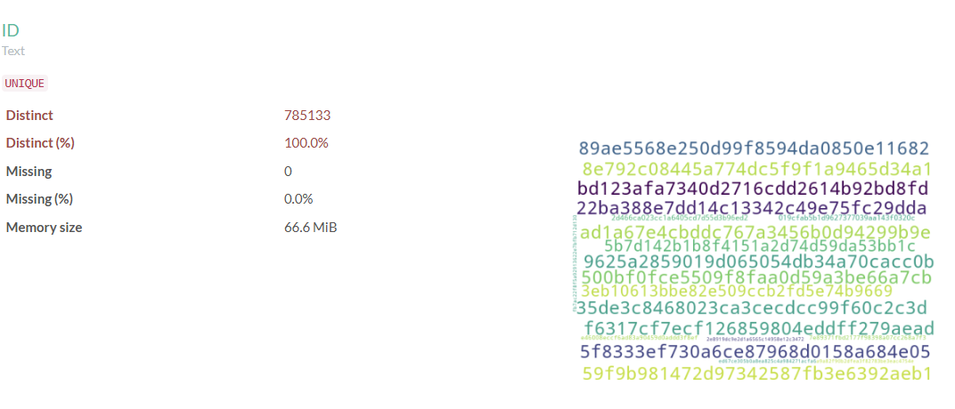
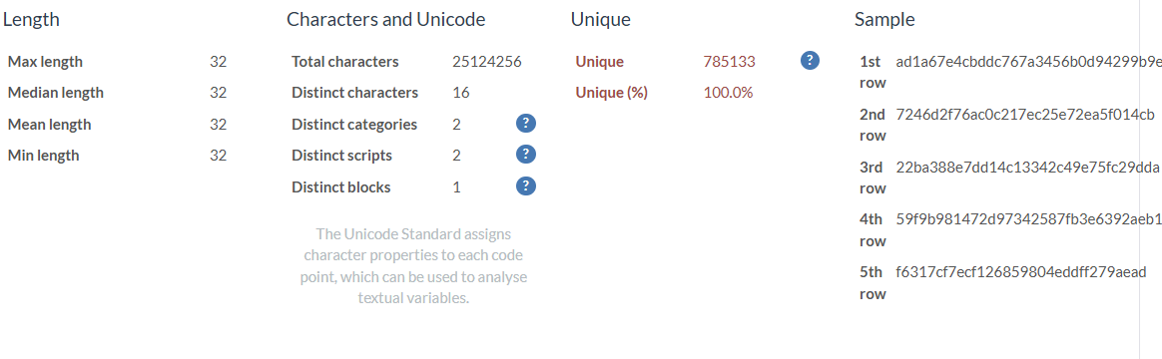

EDA-Column0
This column has missing values. The data consists of real numbers, but there are some missing values. To address this, the strategy is to replace the missing values with zero. This approach is based on the assumption that when no data is available, it can reasonably be interpreted as zero or null.

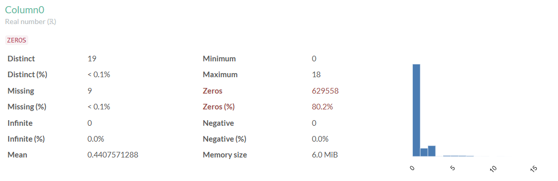
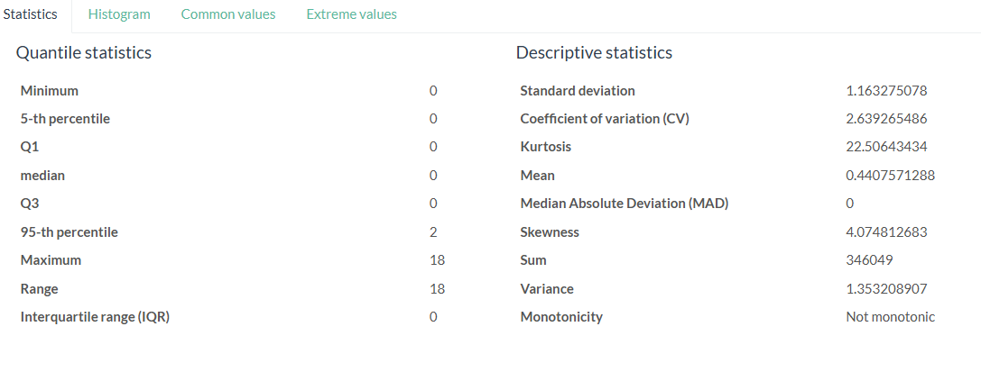

EDA-Column1
No special handling required
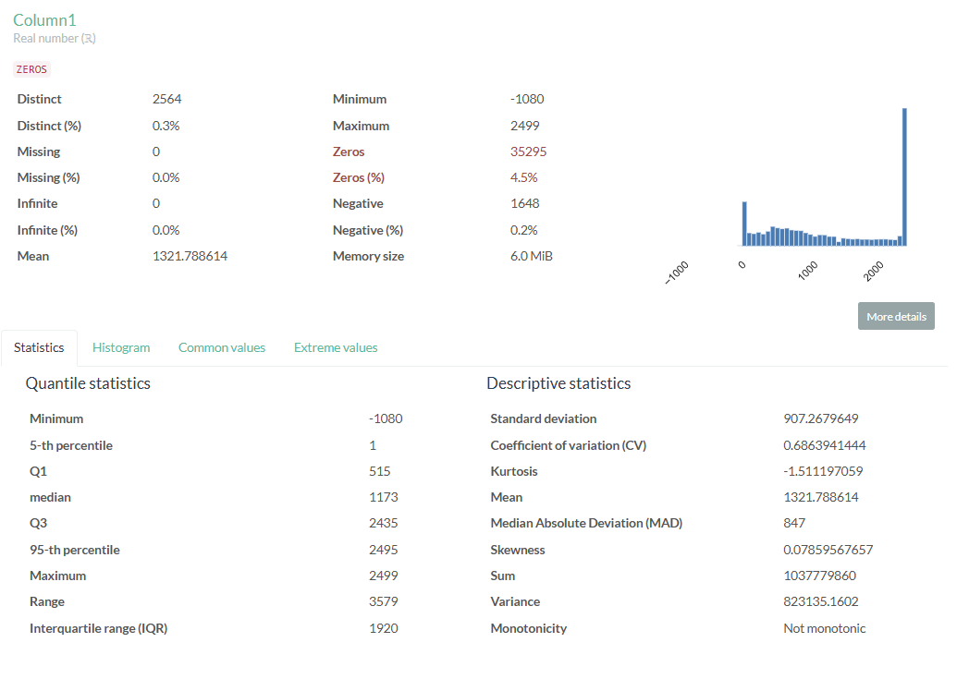

EDA-Column2
No special handling required
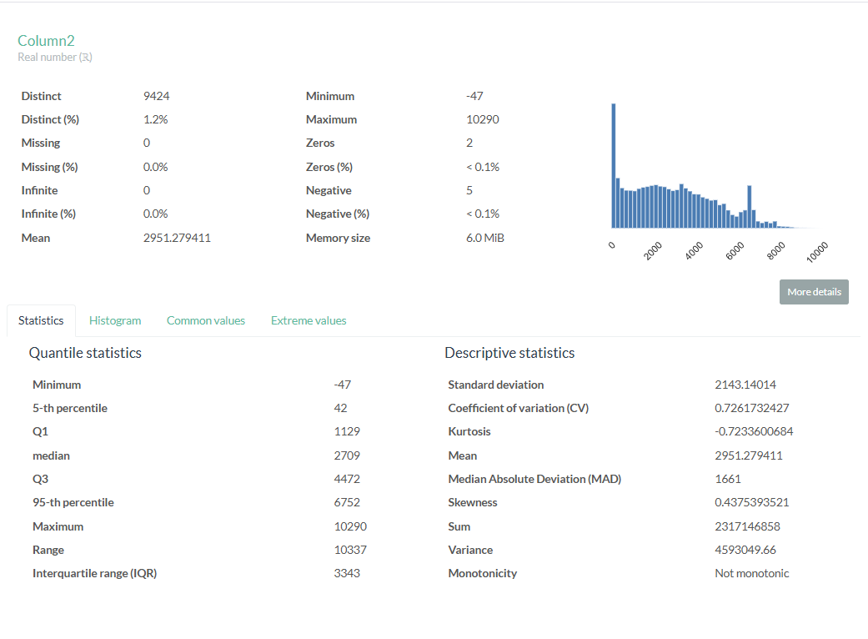

EDA-Column3
This column has missing values. The column is densely corelated to Column4 as mentioned in Co-relation analysis section of this report .This column will be dropped from data modelling to avoid data redundancy.
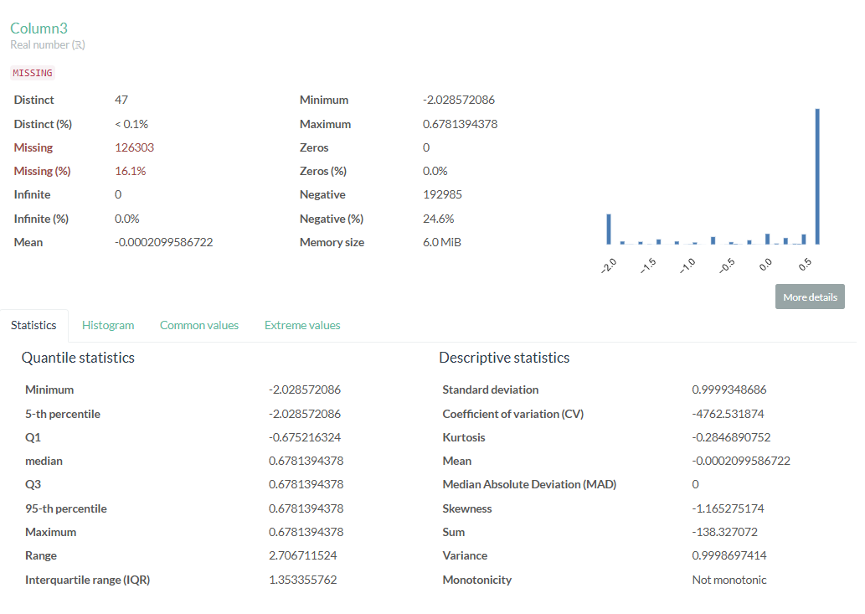

EDA-Column4
This column contains missing values and, as noted, its values are highly correlated with those in column3. The strategy will be to replace the missing values with the median of the column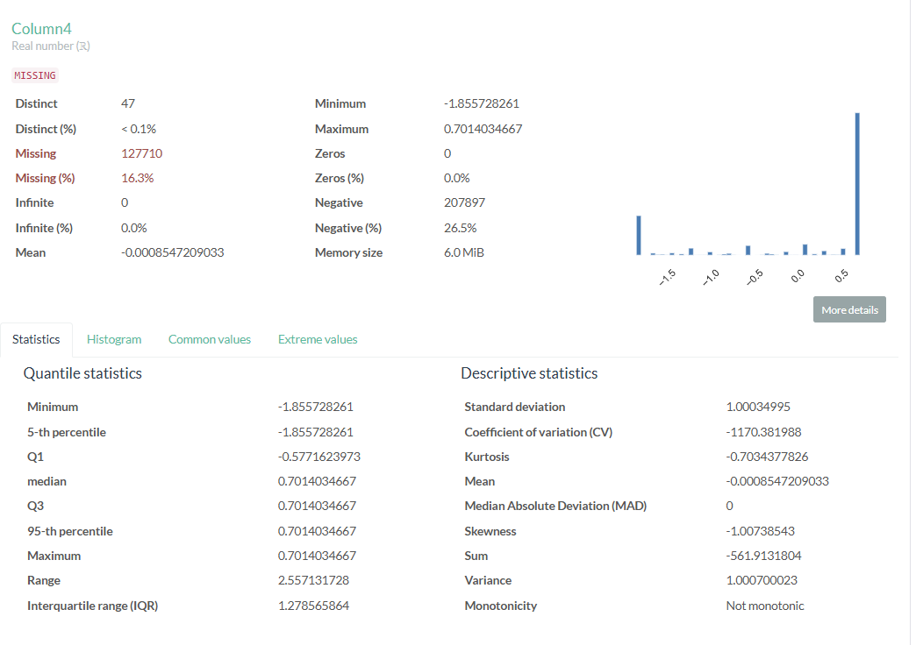

EDA-Column5
This column contains missing values and exhibits skewness. Transforming skewed data is crucial for enhancing the performance of statistical models and ensuring that normality assumptions are satisfied. Data cleaning will be necessary for the model, especially since a significant amount of data is missing. Given that this column consists of real numbers, we can replace the missing values with zero. Additionally, since the data is skewed and includes negative values, the Yeo-Johnson transformation can be applied.
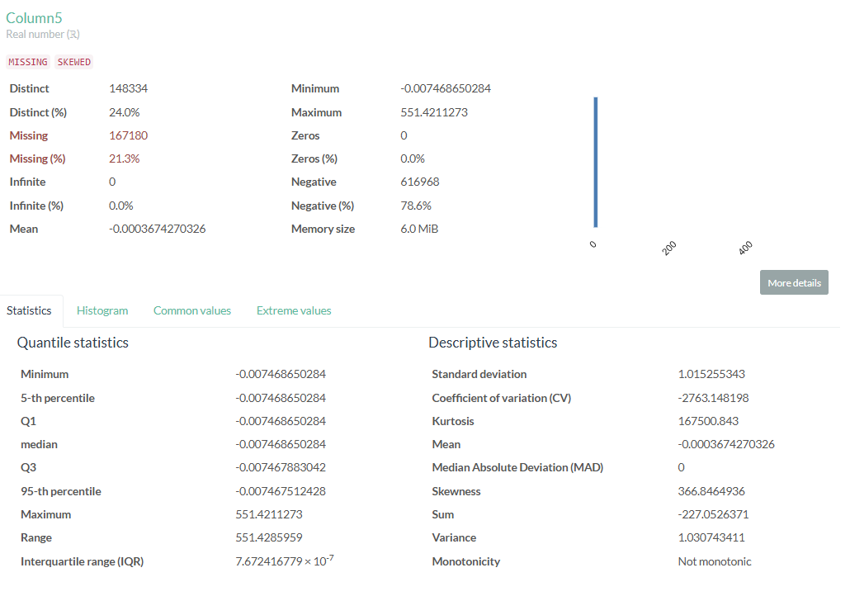

EDA-Column6
This column has missing values. The data consists of real numbers, but there are some missing values. To address this, the strategy is to replace the missing values with zero. This approach is based on the assumption that when no data is available, it can reasonably be interpreted as zero or null.

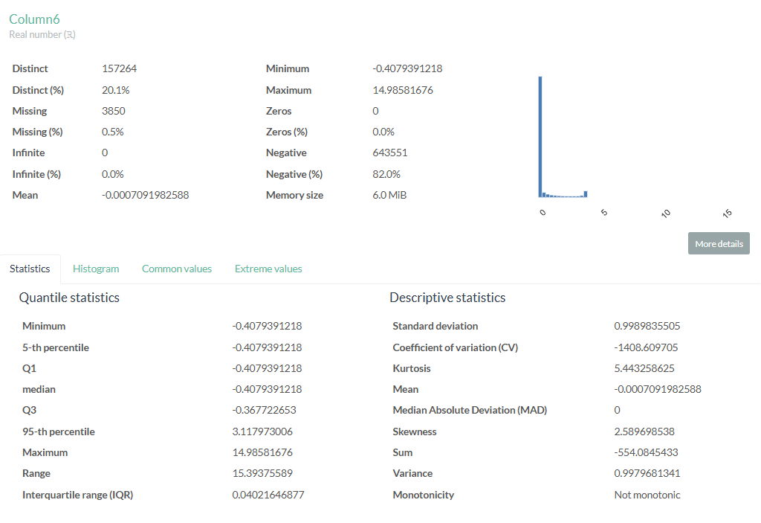

EDA-Column7
This column exhibits skewness. Transforming skewed data is crucial for enhancing the performance of statistical models and ensuring that normality assumptions are satisfied. Data cleaning will be necessary for the model, especially since a significant amount of data is missing. Given that this column consists of real numbers, we can replace the missing values with zero. Additionally, since the data is skewed and includes negative values, the Yeo-Johnson transformation can be applied.

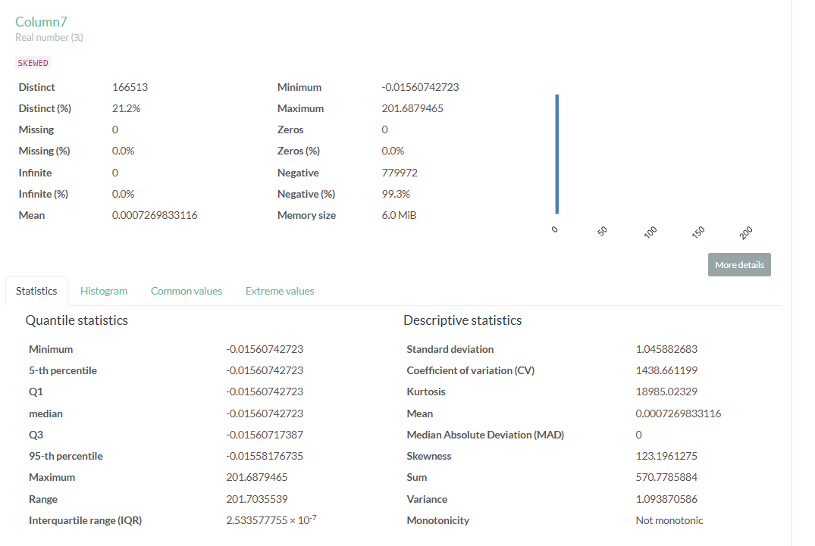

EDA-Column8
This column contains missing values and exhibits skewness. Transforming skewed data is crucial for enhancing the performance of statistical models and ensuring that normality assumptions are satisfied. Data cleaning will be necessary for the model, especially since a significant amount of data is missing. Given that this column consists of real numbers, we can replace the missing values with zero. Additionally, since the data is skewed and includes negative values, the Yeo-Johnson transformation can be applied.

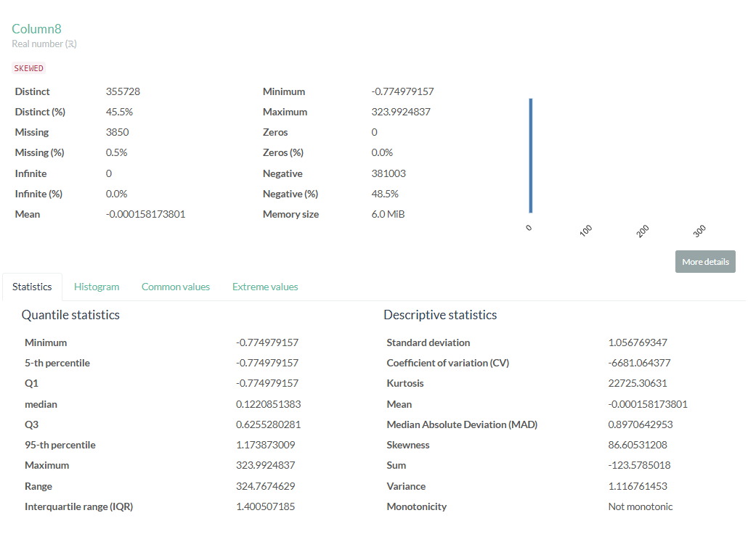

EDA-Column9
This column contains missing values and exhibits skewness. Transforming skewed data is crucial for enhancing the performance of statistical models and ensuring that normality assumptions are satisfied. Data cleaning will be necessary for the model, especially since a significant amount of data is missing. Given that this column consists of real numbers, we can replace the missing values with zero. Additionally, since the data is skewed and includes negative values, the Yeo-Johnson transformation can be applied.
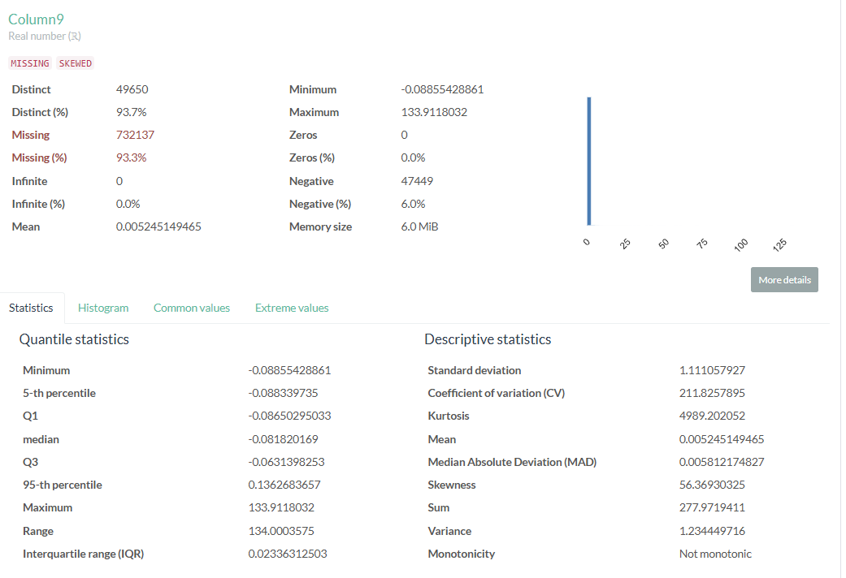

EDA-Column10
This column contains two distinct values, 0 and 1, which likely represent class labels or indicate Yes/No type data. No transformation is required, as most machine learning models can directly work with this column.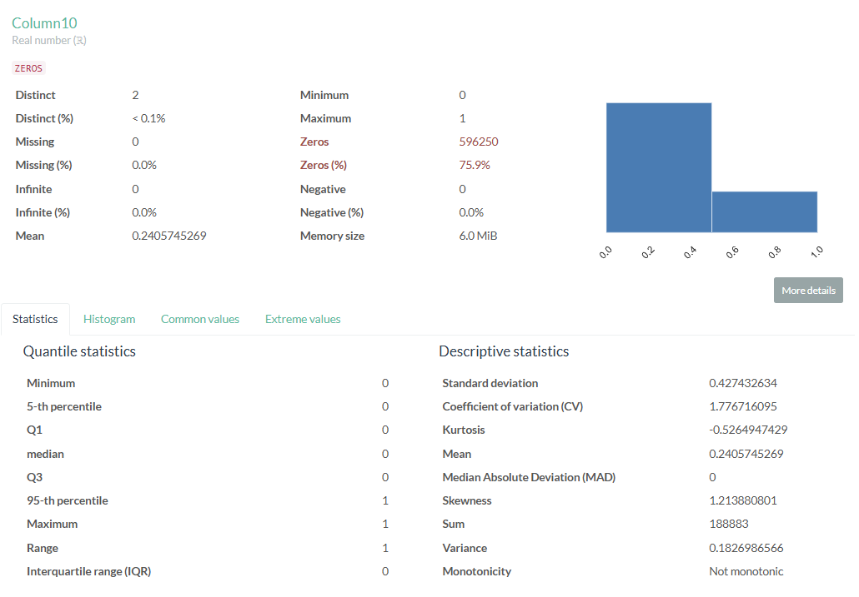

EDA-Column11
This column contains two distinct values, 0 and 1, which likely represent class labels or indicate Yes/No type data. No transformation is required, as most machine learning models can directly work with this column.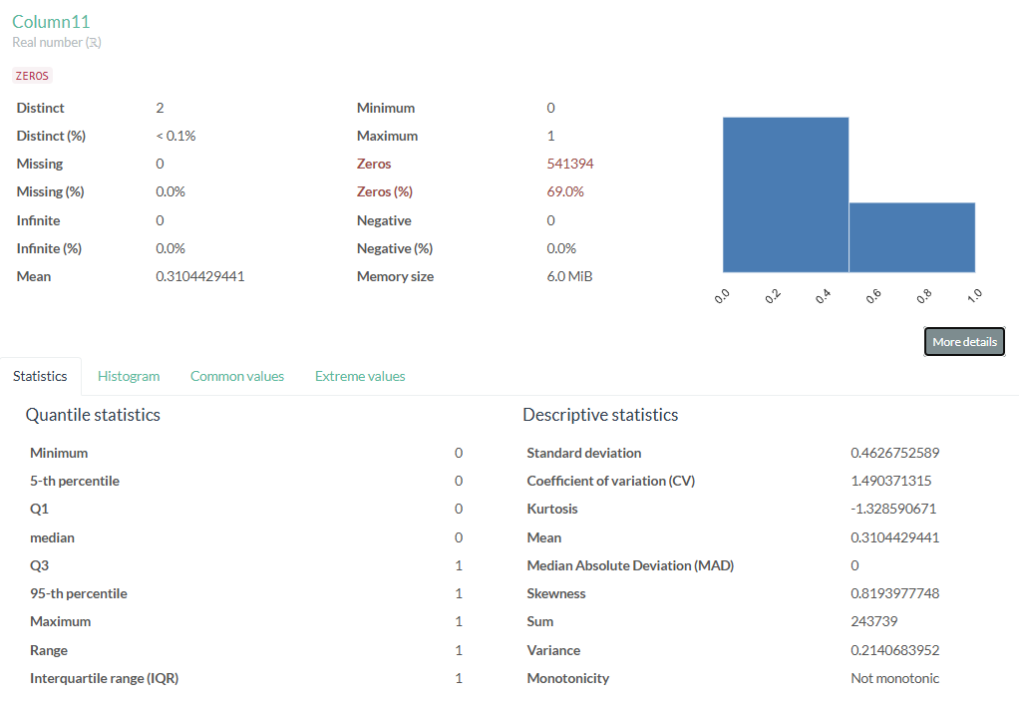

EDA-Column12
This column contains two distinct values, 0 and 1, which likely represent class labels or indicate Yes/No type data. No transformation is required, as most machine learning models can directly work with this column.
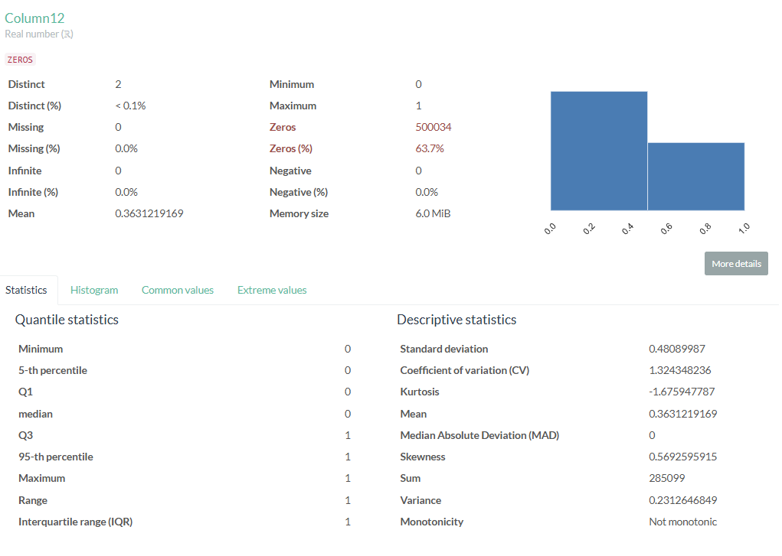

EDA-Column13
This column contains two distinct values, 0 and 1, which likely represent class labels or indicate Yes/No type data. No transformation is required, as most machine learning models can directly work with this column. As mentioned in the Co-Relation analysis section this column is highly co-related to column10, column11 and column12. From data modelling those columns will be dropped.

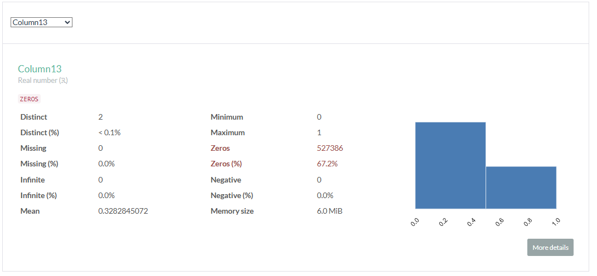

EDA-Column14
This column contains missing values and exhibits skewness. Transforming skewed data is crucial for enhancing the performance of statistical models and ensuring that normality assumptions are satisfied. Data cleaning will be necessary for the model, especially since a significant amount of data is missing. Given that this column consists of real numbers, we can replace the missing values with zero. Additionally, since the data is skewed and includes negative values, the Yeo-Johnson transformation can be applied.

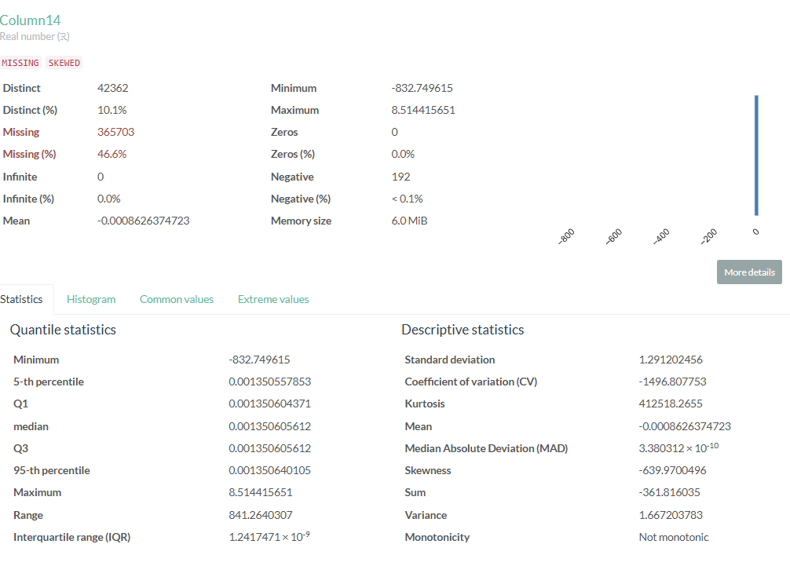

EDA-Column15
This column contains missing values and exhibits skewness. Transforming skewed data is crucial for enhancing the performance of statistical models and ensuring that normality assumptions are satisfied. Data cleaning will be necessary for the model, especially since a significant amount of data is missing. Given that this column consists of real numbers, we can replace the missing values with zero. Additionally, since the data is skewed and includes negative values, the Yeo-Johnson transformation can be applied.
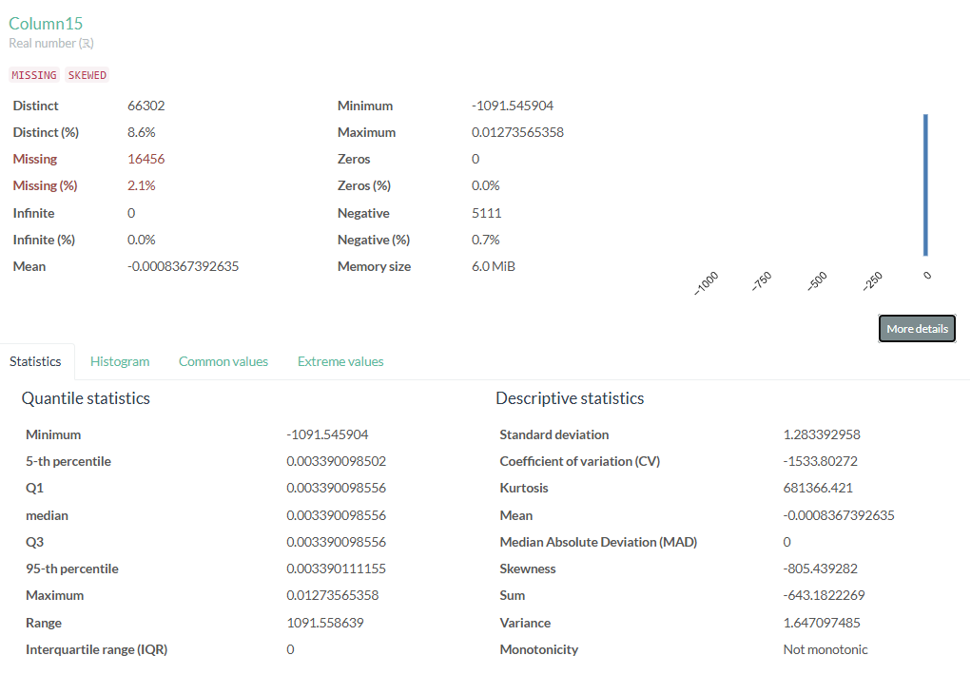

EDA-Column16
This column data is SKEWED. However there are only 3 distinct values i.e 0,1,2. It seems data is already transformed for some class values. There is no need for further transformation
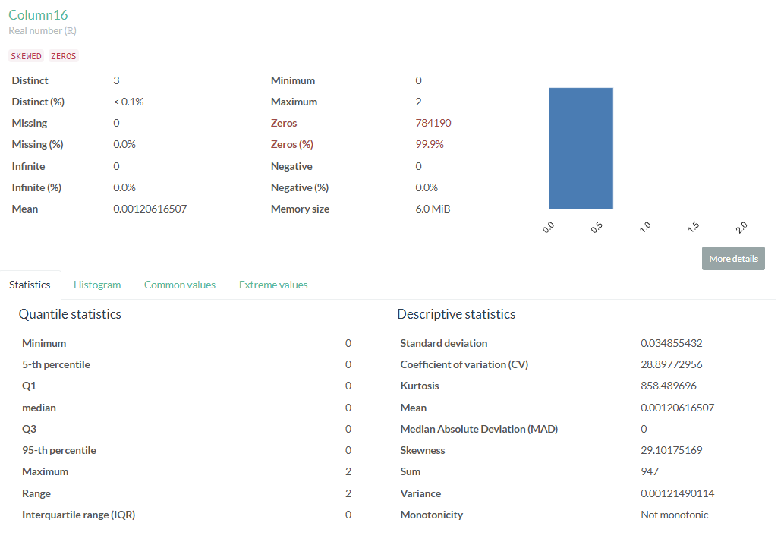

EDA-Column17
This column exhibits skewness. Transforming skewed data is crucial for enhancing the performance of statistical models and ensuring that normality assumptions are satisfied. Data cleaning will be necessary for the model, especially since a significant amount of data is missing. Given that this column consists of real numbers, we can replace the missing values with zero. Additionally, since the data is skewed and includes negative values, the Yeo-Johnson transformation can be applied.
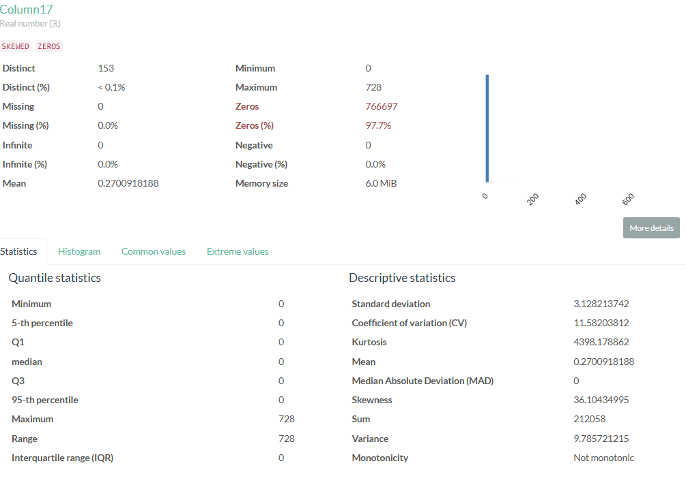

EDA-Column18
The column predominantly contains zeros, indicating that the data is skewed. However, it includes only three distinct values ranging from 0 to 9, suggesting that the data has already been transformed for certain class values. No additional transformation is necessary.
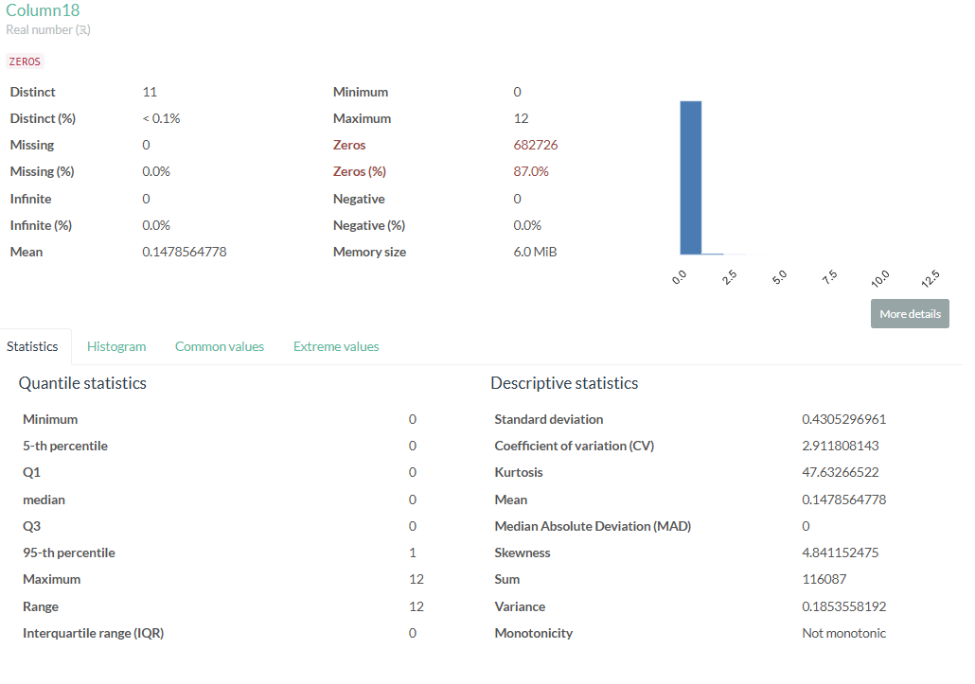

EDA-Column19
The column predominantly contains zeros, indicating that the data is skewed. However, it includes only three distinct values ranging from 0 to 1, suggesting that the data has already been transformed for certain class values. No additional transformation is necessary.
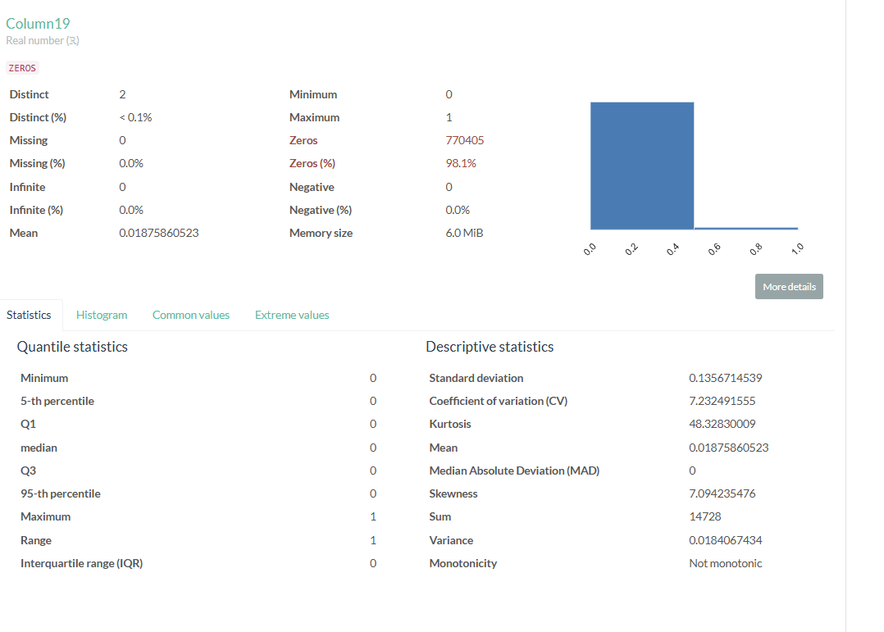

EDA-Column20
The column predominantly contains zeros, indicating that the data is skewed. However, it includes only three distinct values ranging from 0 to 1, suggesting that the data has already been transformed for certain class values. No additional transformation is necessary.

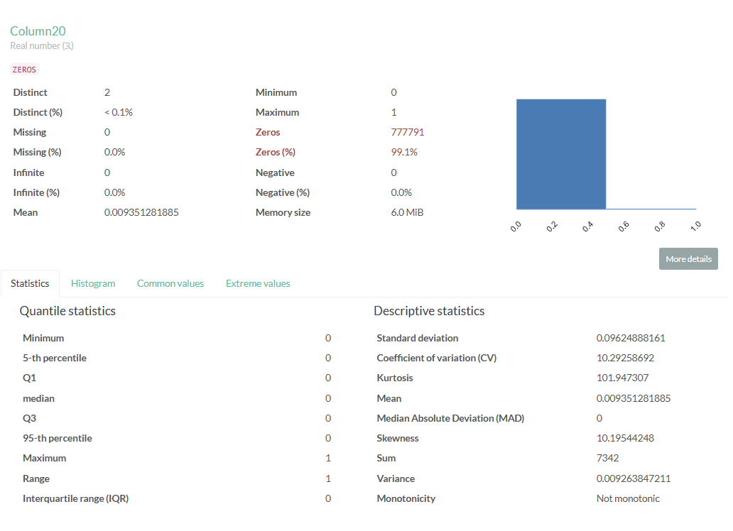

EDA-Column21
The column predominantly contains zeros, indicating that the data is skewed. However, it includes only three distinct values ranging from 0 to 1, suggesting that the data has already been transformed for certain class values. No additional transformation is necessary.

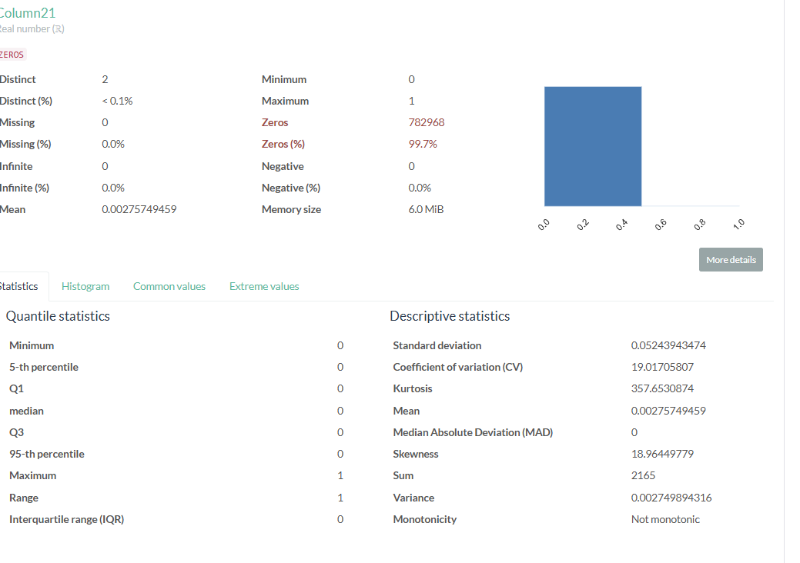

Co-Relation analysis
Certain columns exhibit a high degree of correlation with one another and should be removed from the modeling process to reduce data redundancy. For instance, column3 and column4 are significantly correlated. Additionally, columns 10 through 13 also show a strong correlation.
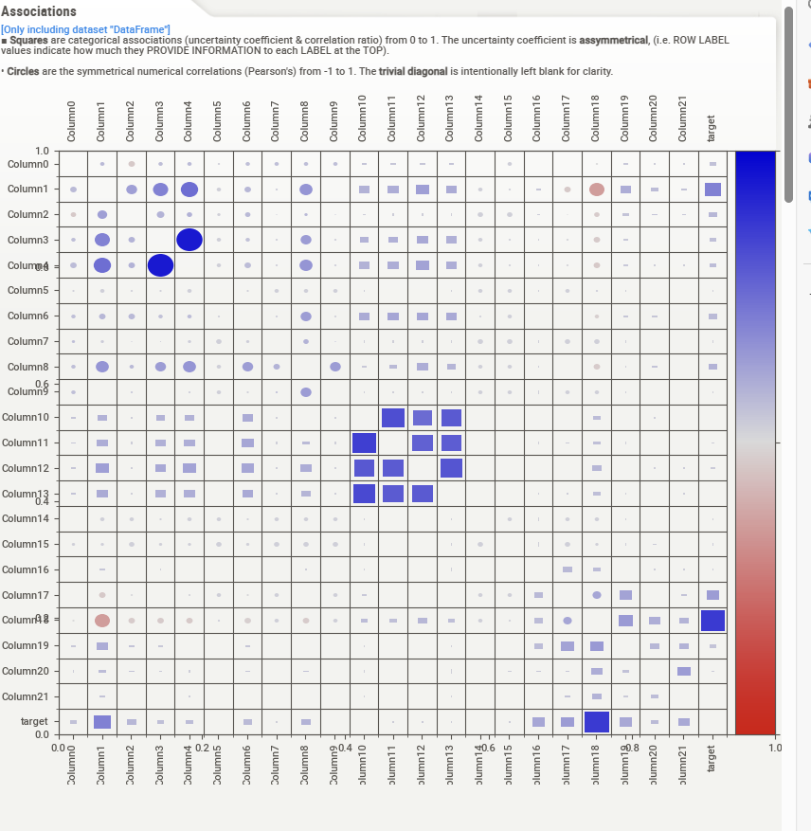

Target Class distribution
As evident from the graph below dataset is highly imbalanced for target variable class_0

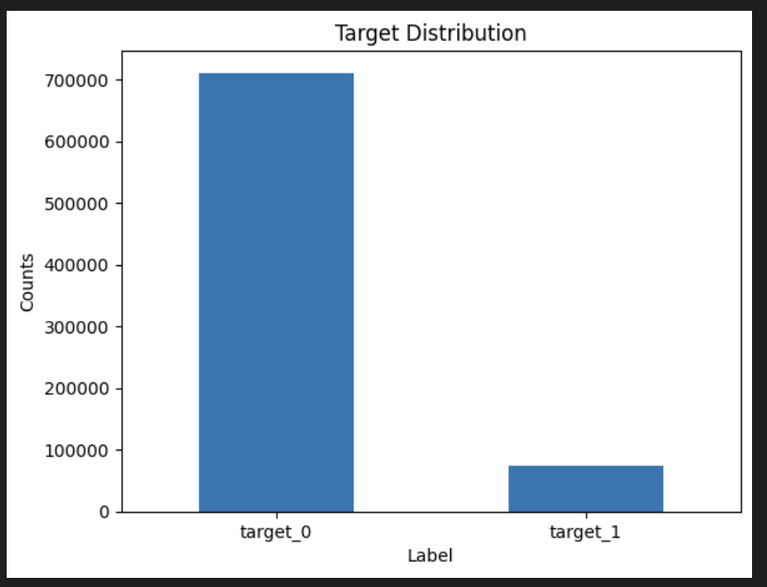

Data Modelling – Logistic Regression
Since the target variable has binary data , Logistic regression is good algorithm for prediction.
All the independent variables will be used to predict the value of target variable

Model Performance Report

Model performance on training data
Auc Score: 92.892%
Eval Accuracy: 96.890%
ROC Curve
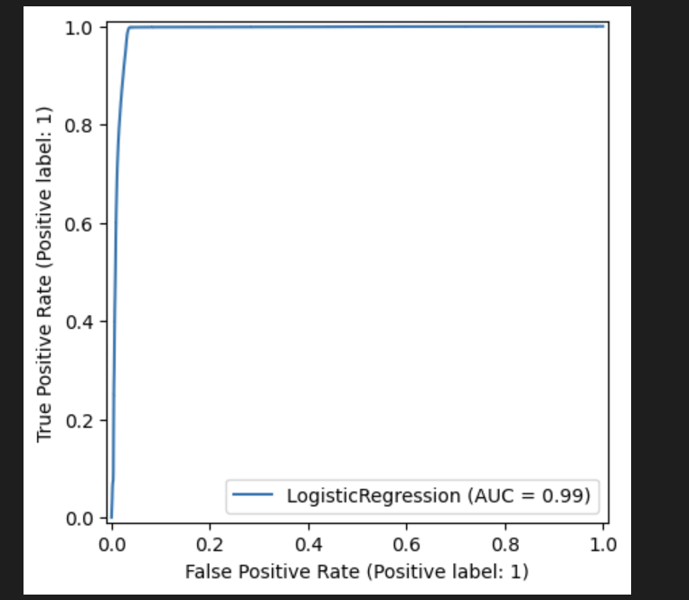

Model performance on Test data
Auc Score: 93.334%
Eval Accuracy: 96.970%
ROC Curve
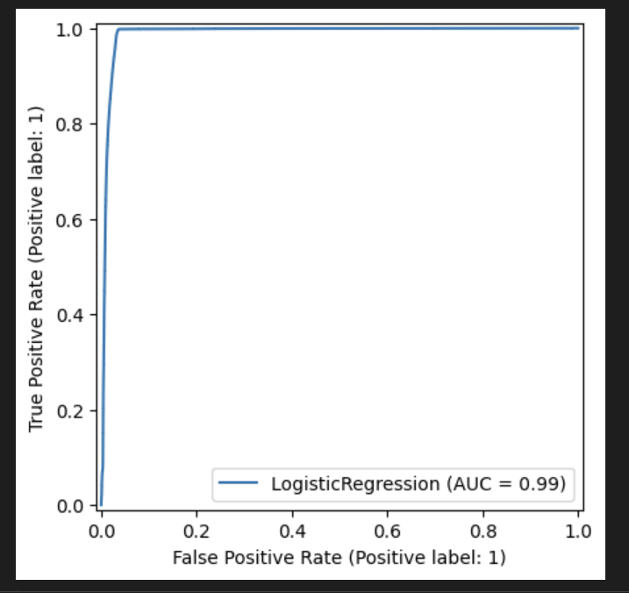

Results Summary

Logistic Regression Model Summary
- Model Type: Logistic Regression
- AUC (Area Under ROC Curve): 93.334%
  - The AUC score represents the ability of the model to distinguish between classes. A score of 93.334% indicates excellent model performance, as values closer to 100% show better classification.
- Evaluation Accuracy: 96.970%
  - This accuracy indicates that 96.970% of the predictions made by the model were correct. It's a strong indicator of the model's overall performance on the evaluation dataset.
Key Insights:
- The high AUC score suggests that the model effectively distinguishes between the positive and negative classes.
- The Evaluation Accuracy reflects the overall proportion of correctly predicted labels, with nearly 97% of predictions being correct.
Conclusion:
The Logistic Regression model shows strong performance with a high AUC score and evaluation accuracy, indicating that it is well-suited for the current dataset.

